LEDVANCE GmbH, Parkring 1–5, 85748 Garching bei München
Manufacturer's Declaration

Project: Compatibility of the LEDVANCE EL KIT COMP 55V 4W LI MT AT 3H WT
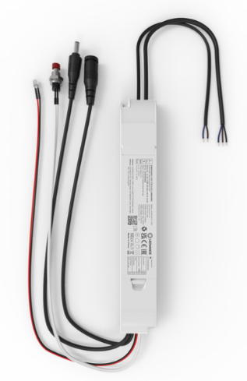
Supplier: LEDVANCE GmbH
Parkring 1-5
85748 Garching bei München

Products:

4058075860711 | EL KIT COMP 55V 4W LI MT AT 3H WT

Above mentioned EM Conversion KIT is only suitable and has full certification in combination with following luminaire families:

- Panel Compact GEN2
- Panel Surface
- Panel Eco GEN3
- Panel Compact Tpa
- Spot Vario Gen 2

Instructions in the individual product user manuals need to be respected and applied accordingly.

LEDVANCE GmbH
Latest version 09. June 2026

